|  |  |
| --- | --- |
|  |  |
|  |



**Wisdom heals childlike innocence**

**WiseSpirit**

**Work innovation analysis report**

**Version: V 3 . 1 . 2**

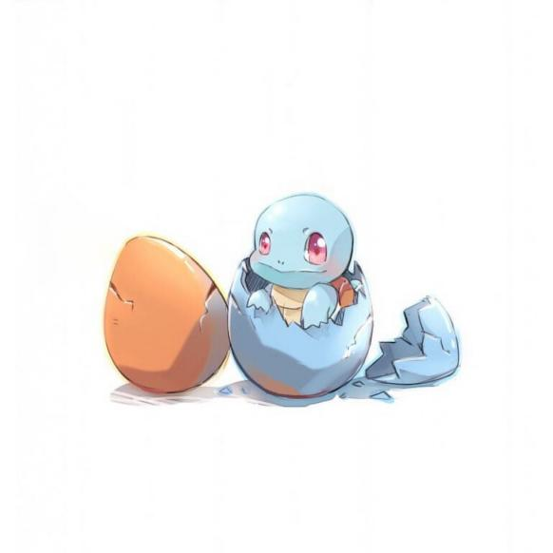

morning bell

**2023-2-27**

**All Rights Reserved**

Table of contents

1 Pain point analysis 1

1.1 Overview of pain points 1

1.2 Related work 2

2 Project Innovation Points 4

2.1 Technical innovation points 4

2.1.1 High touch accuracy interaction technology 4

2.1.2 Video-based diagnosis mechanism of stereotyped movements in children with ASD 5

2.1.3 ASD children’s diagnosis and attention discrimination mechanism based on EEG and eye movement recognition 7

2.2 Functional innovation points 7

2.2.1 New methods of rehabilitation training 7

2.2.2 Aquarium interaction mode 8

3 Competitive product analysis 9

3.1 Diagnosis comparison 9

3.2 Rehabilitation training comparison 9

3.3 Training evaluation comparison 10

Document revision history

|  |  |  |  |  |  |
| --- | --- | --- | --- | --- | --- |
| **serial number** | **Reason for revision** | **version number** | **author** | **Revision date** | **Remark** |
| **1** | **Create pain point analysis and competitive product analysis modules** | **V1.0.1** | **Team member A** | **202 2.12.20 _** | **Complete all pain point analysis content and initially complete the content of the competitive product analysis module** |
| **2** | **Update competitive product analysis module** | **V1.0.2** | **Team member A** | **202 2.12.22 _** | **Complete all content of competitive product analysis** |
| **3** | **Create project innovation module** | **V1.0.3** | **Team member D** | **202 2 .12.2 5** | **Complete the content of the technical innovation point module** |
| **4** | **Update project innovation module** | **V1.0.4** | **Team member A** | **2022.12.25** | **Complete the functional innovation module content** |
| **5** | **Update project innovation module** | **V1.1.1** | **Team member A** | **2022.12.27** | **Improve the content of the technical innovation module** |
| **6** | **Update competitive product analysis module** | **V1.1.2** | **Team member D** | **2022.12.28** | **Correct the content of competitive product analysis module** |
| **7** | **Update entire document** | **V1.2.1** | **Team member D** | **2022.12.29** | **Check and fill in gaps in all document contents** |
| **8** | **Update entire document** | **V1.2.2** | **Team member A** | **2022.12.30** | **Secondary inspection, focusing on document format, such as directory structure and typesetting** |
| **9** | **Update competitive product analysis table** | **V2.0.1** | **Team member A** | **2023. 01. 02 _ _** | **Improve the content of the competitive product analysis table and beautify the format** |
| **10** | **Update project innovation module** | **V2.0.2** | **Team member A** | **2023. 01. 04 _ _** | **Improve the content of the technical innovation module** |
| **11** | **Update entire document** | **V2.1.1** | **Team member D** | **2023. 01. 04 _ _** | **Check and fill in gaps in all document contents** |
| **12** | **Update entire document** | **V2.1.2** | **Team member A** | **2023. 01. 07 _ _** | **Secondary inspection, focusing on document format, such as directory structure and typesetting** |
| **13** | **Update technological innovation points** | **V3.0.1** | **Team member A** | **2023.01.11 _ _ _ _** | **Re-modify the content of technological innovation points according to the technical framework adjustment** |
| **14** | **Modify wording** | **V3.0.2** | **Team member A** | **2023.01.13 _ _ _ _** | **Modify inappropriate words or illogical statements in the document** |
| **15** | **Review entire document** | **V3.1.1** | **Team member A** | **2023.01.15 _ _ _ _** | **Review document content and formatting** |
| **16** | **Review entire document** | **V3.1.2** | **Team member D** | **2023.01.16 _ _ _ _** | **Secondary review of document content and layout** |

# 1 Pain point analysis

## Pain point overview

**Autism spectrum disorder** ( **ASD** ) is a series of complex **neurodevelopmental disorders** that affect social, communication and behavioral abilities. For ASD, **childhood is a critical period for recovery** , and early diagnosis is crucial to the recovery of ASD patients. According to estimates from the CDC's ASD and Developmental Disabilities Monitoring Network (ADDM), approximately 1 in 54 children has ASD, and the prevalence is **increasing** .

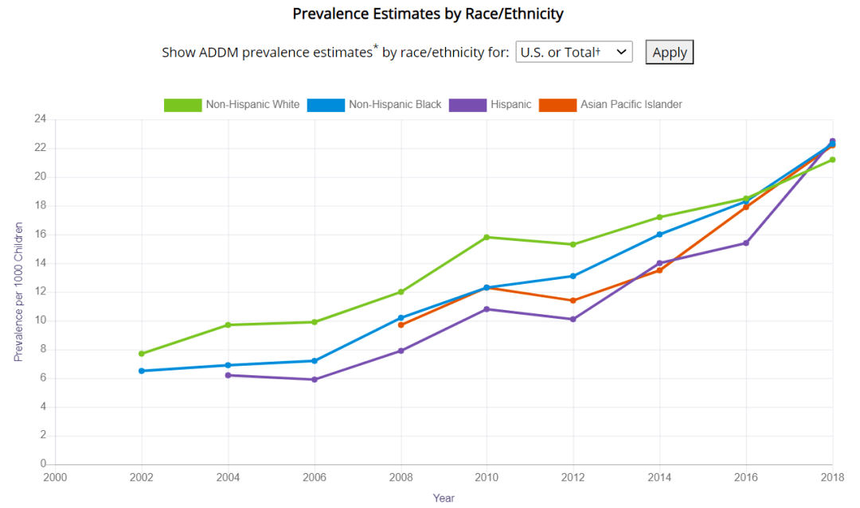

Existing methods for diagnosing ASD are often used by professionals through parent interviews, clinical testing of patients, or a combination of the two methods as the standard for diagnosing ASD. However, in practice, these methods cannot well meet the needs of diagnosis and treatment of children with ASD . The details are as follows :

**1 . Assessment results lack real-time and objectivity**

Currently, most of the existing ASD assessment and diagnosis methods are **subjective assessment** and **post-assessment** . The assessment lacks unified objective standards . At the same time, the assessment results must be obtained after a series of completed assessment processes . There is no way to obtain the assessment results based on the assessment process in real time. .

**2 . Not sufficiently consistent with the cognitive and behavioral characteristics of individuals with ASD**

will have some unique cognitive and behavioral characteristics due to their own defects caused by the disease . The current assessment and training methods lack the consideration of these unique cognitive and behavioral characteristics of children with ASD , resulting in some training and Assessment methods are difficult for children with ASD to accept and actively participate in .

For example, many traditional cognitive and behavioral interventions are **delivered by therapists through verbal, behavioral, or pictorial guidance** . For children with ASD, these treatment methods **are not intuitive and vivid enough** , and it is difficult to stimulate their participation motivation and attention orientation in tasks, and achieve effective training effects.

**3 . Hardware facilities are limited**

Most of the existing computer-aided diagnosis methods require **wearing expensive collection equipment to collect the corresponding data of children with ASD** in **an unnatural state , which is not accurate and convenient enough** for diagnosis .

Moreover, existing **VR/AR** technologies and training models are rarely suitable for young ASD patients under 6 years old, and **head-mounted displays (HMDs) have adverse effects on young children's visual function and comfort** .

**4 . Diagnosis and treatment thresholds are high**

Traditional diagnosis and treatment methods require going to prescribed medical facilities and having corresponding medical staff perform the diagnosis and treatment . The cost and threshold of diagnosis and treatment are high , and there are pain points that make it difficult to achieve home treatment .

**5 . Ignoring the psychological pressure of patients’ families**

Most of the patients are children , and the family members of ASD patients inevitably have to bear heavy psychological pressure . The traditional diagnosis and rehabilitation treatment methods ignore the psychological pressure of the patients' family members and fail to release the pressure and alleviate the emotions of the patients' family members . And many family members suffer from various objective restrictions and have no way to obtain timely information about various related ASD conditions .

## Related work

As of now , there is no objective solution for the diagnosis and treatment of children with ASD in the relevant field . Most related solutions can only solve the urgent needs of diagnosis and treatment of ASD children , and their effectiveness in solving the above-mentioned deep-seated problems is very limited :

**1 . Assessment results lack real-time and objectivity**

In view of the **lack of real-time and objectivity of assessment results ,** professionals use parent interviews, clinical patient testing, and a combination of the two methods as the standard for diagnosing ASD. Based on this standard , the assessment process is gradually improved to make it as possible as possible. Achieve real-time delivery of staged results of assessment and diagnosis . However, unified standards still lack consideration for children with special ASD . The process of diagnosis and evaluation is relatively complicated , and it is necessary to strengthen the training of professional skills of medical staff .

**2 . Not sufficiently consistent with the cognitive and behavioral characteristics of individuals with ASD**

In response to the pain point of **not meeting the cognitive and behavioral characteristics of ASD individuals** , some traditional cognitive and behavioral intervention methods are **implemented by therapists through verbal, behavioral or picture guidance** , and are based on the actions of ASD children in the test. , real-time changes in intervention methods . However, for children with ASD, these treatment methods **are not intuitive and vivid enough** , and it is difficult to stimulate their participation motivation and attention orientation in tasks, so as to achieve effective training effects.

**3 . Hardware facilities are limited**

In response to the pain point of **limited hardware facilities** , some diagnostic technologies have introduced VR / AR technology , but existing **VR/AR** technologies and training models are rarely suitable for young ASD patients under 6 years old. **Head-mounted displays (HMD) It has a negative impact on the visual function and comfort of young children** .

**4 . Diagnosis and treatment thresholds are high**

In view of the pain point of **high diagnosis and treatment threshold** , the current simpler solution is to hire professional medical personnel to go to the families of patients and children to treat the children , but this method is still costly .

# Project innovation points

## Technical innovation points

### High touch accuracy interaction technology

**1 . Moving viewpoint method based on fused water refraction**

The interface buttons are displayed on the rear glass of the aquarium (that is, the glass close to the user), and with the help of the infrared touch frame embedded on the front glass of the aquarium, the user's perspective is combined with the water refraction problem to realize the user's Intuitive interaction with interface buttons provides a more realistic touch interaction experience.

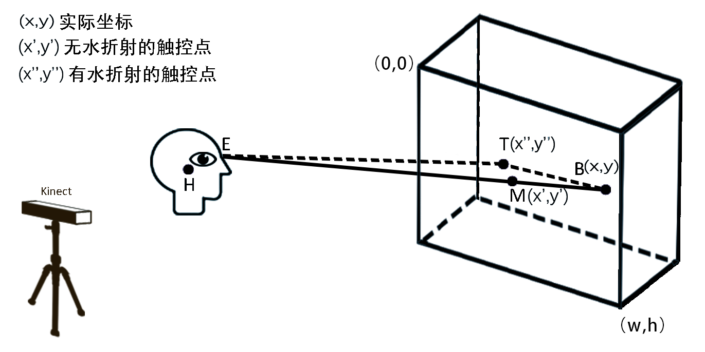

Key coordinate points of touch interaction in MR aquarium cognitive rehabilitation training mode

**2 . Optimization method based on Kinect eye tracking**

The user behavior status is detected before changing the head position height value y. When the user is in a gentle movement state, the head position height value y is locked during the head position detection system; and when the user breaks away from the gentle movement, the head position height value y is When the height value y changes significantly, such as squatting, jumping, etc., the head position height value y is released, so that the head position height value can change in real time with the user's movement.

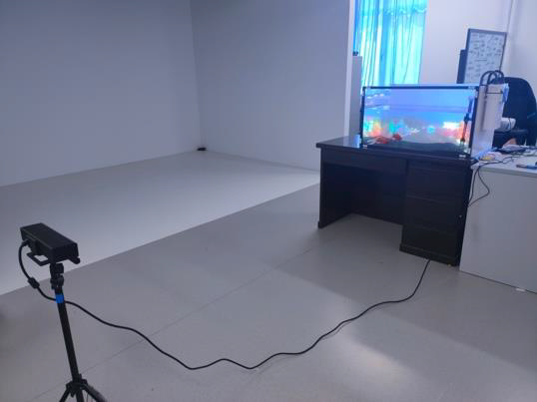

Kinect placed in front of the aquarium to track users

### Video-based diagnosis mechanism of stereotyped movements in children with ASD

**1. Time series data identification method based on multi-scale information fusion**

We propose a temporal network that fuses multi-scale local correlation information and uses an attention mechanism, as shown in the figure. Using the LSTM-based network as the backbone network, before the data is input into the backbone network, it passes through a multi-window size feature extraction module, allowing the model to extract relevant information from local data at different scales; we also added attention to the classification network The force mechanism makes the training of the network better constrained.

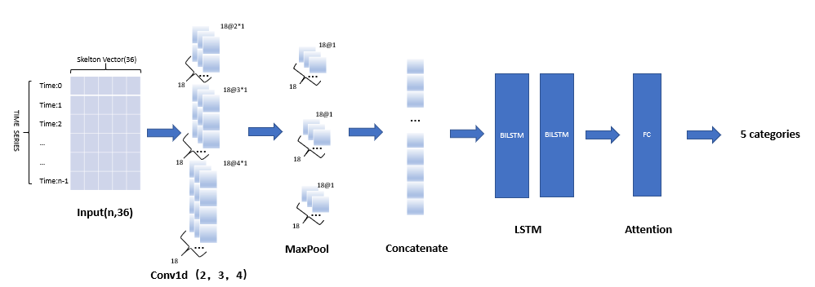

Network structure

**2. Construction of video-based stereotype action data set**

This study used a fixed-position non-depth camera to record and screen the stereotyped behaviors of children with ASD during class for a long time, and finally selected 6 children as the research subjects. A total of two cameras are set up, one is placed directly above the aquarium, the camera is facing the child, and the child faces the camera, which is used to record the performance of the child during the entire training process. A camera is located on the side of the aquarium and is mainly used to record the performance of children during actual operations .

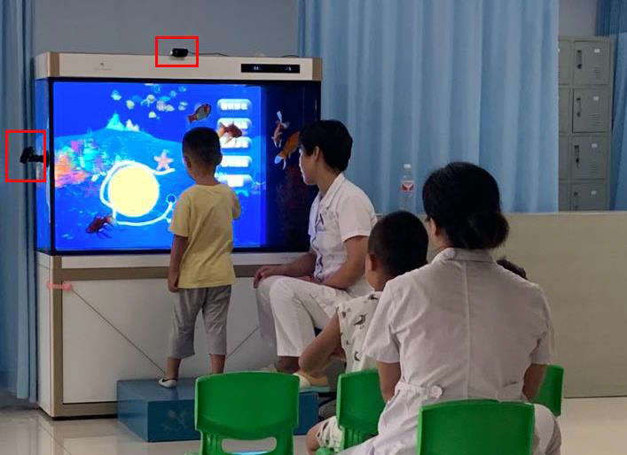

Video data collection environment

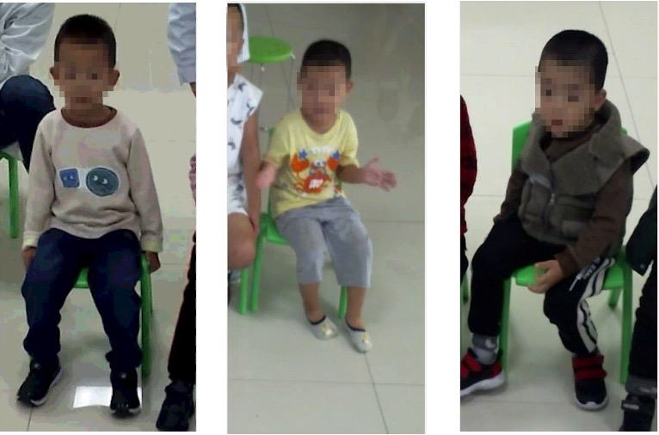

(a) Body shaking (b) Repeated clapping (c) Excessive movement

Examples of children's action videos with different stereotyped actions

### based on EEG and eye movement recognition

Due to irregular processing in the brain, early detection of abnormalities in ASD patients can be achieved using electroencephalography (EEG). Computer-aided diagnostic tools can be used to identify subtle and invisible information present in irregular EEG patterns and diagnose autism. We use auxiliary ASD diagnostic methods based on discrete wavelet transform (DWT), entropy (En) , and artificial neural networks to effectively differentiate ASD patients from typical developing patients . And during the training process , by detecting the patient's brain waves in real time , the degree of concentration during training can be judged .

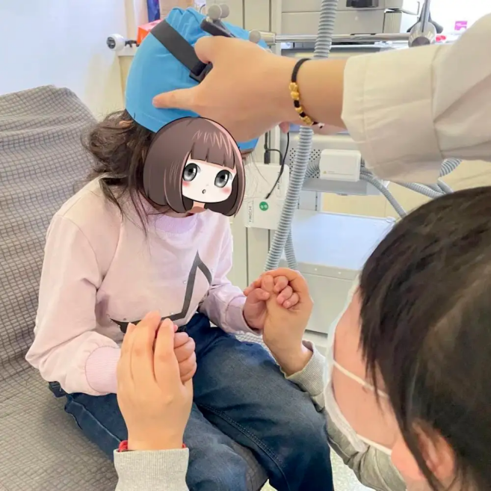

## Functional innovation points

### New methods of rehabilitation training

The overall design of an MR-based interactive aquarium should include three main aspects, as shown in the figure.

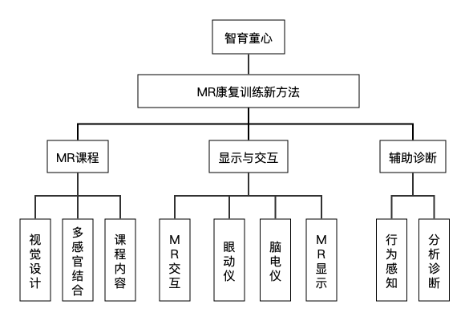

The system architecture includes **MR course design, MR display and interaction design, and computing-aided diagnosis design** . Among them, MR course design includes visual design, course content design and multi-sensory integration design; display and interaction design includes MR display design and MR interaction design integrated with the display environment; computer-aided diagnosis design in MR mode includes behavioral perception of children with ASD Design and analyze diagnostic design.

**2. Visual design of MR rehabilitation training**

The virtual course content in the MR training mode of the work is in line with the visual perception characteristics of children with ASD. After reviewing literature and conducting field surveys, the team members **conducted research** on the perspective, sense of space, color, and style of the virtual scene , and determined the most suitable parameters for children with ASD by reviewing papers and conducting field surveys.

**3. Multimodal feedback for MR rehabilitation training**

**Visually** , this design uses the external characteristics of virtual sea creatures to consolidate the cognitive content and expand the cognitive scope of children with ASD. In terms of **hearing** , according to the opinions of the therapist, sound stimulation that can help stimulate the interest and attention of children with ASD is selected as the sound feedback in the training system, and relaxing music is added to help them regulate their emotions. In addition, children with ASD are given more **vivid and clear learning feedback** by combining vision and hearing . In addition, the MR-based interactive aquarium simplifies the therapist's operations and reduces their physical load during training.

**4. MR display and interaction**

**virtual projection superimposed** on the aquarium . The 3D virtual content of the theme course is displayed through LCD dimming film and projection equipment, realizing **the combination of real aquarium and virtual training content** , enhancing the immersion of children with ASD.

Touch interaction is used as a natural interaction method suitable for children with ASD in an MR rehabilitation training model based on an aquarium. The infrared touch frame placed on the front of the aquarium identifies the click position of the user's finger, and uses the touch landing position as the interactive input. The touch interaction module is implemented through infrared touch technology, and the precise location touched by the user in the virtual environment is identified by the infrared touch frame.

### Aquarium interactive mode

This project consists of real aquariums, computers, training course content, etc. , to achieve intuitive interaction between users and interface buttons .

Using an aquarium as the carrier of this project can significantly improve the concentration of ASD children in the diagnosis and training process and achieve better therapeutic effects . At the same time there is often a gap between ordinary clinical intervention settings and everyday life settings. Therefore, it is difficult for children with ASD to translate experiences gained in the hospital into their daily lives. Different from this, the use of MR training environment **can enhance the connection between training content and daily life** , which is conducive to the transfer of training effects from training courses to daily life. For example, this study uses real aquariums and real fish to learn some knowledge about underwater creatures. This experience can be **directly used in similar situations in daily life** .

### Pay attention to the psychological pressure of family members

For the core aquarium part of this project , the project team developed a targeted mobile APP called "Smart Healing Childhood" , which added a family module . This module focuses on the release of stress and emotional relief of the patient's family . The patient's family can In this module, you can communicate with other patients’ families about their children’s condition , and you can visually see the recovery status of children with ASD .

Families of ASD patients can directly communicate with doctors in this module . At the same time , access to artificial intelligence can automatically recommend relevant professional knowledge based on the keywords entered by the family members based on the knowledge database built by the project team , so that parents can be satisfied. You can share the latest ASD-related professional knowledge without leaving home .

# Competitive product analysis

## diagnostic comparison

The existing traditional methods for diagnosing children with ASD are mainly for professionals to diagnose whether the children involved in the diagnosis have ASD through parent interviews, clinical testing of patients, and a combination of the two methods as criteria for diagnosing ASD . A detailed comparison in terms of cost , diagnostic effect, etc. is as follows :

|  |  |  |
| --- | --- | --- |
|  | Intellectual education of childishness | traditional method |
| Diagnostic equipment needs | Home aquarium , intellectual education software , eye tracker ( optional ), brain wave instrument ( optional ) | Diagnostics with professional knowledge and other teaching aids for auxiliary use |
| Diagnostic effect | Objective and accurate | Relying on the professional level of the diagnostic personnel , it is highly subjective |
| diagnostic cost | Purchase the required equipment one time and do not need to pay other subsequent fees. | Professional diagnosticians charge based on their time , and each diagnosis requires payment |
| Synergy | Children with ASD can be treated simultaneously while diagnosis is made , and training results can be evaluated simultaneously. | The diagnosis of the disease and rehabilitation training are carried out separately . In many cases, the doctor who diagnoses and the doctor who performs rehabilitation treatment are not the same ones. |
| Convenience | The Intelligent Education of Childlike Heart software uses household aquariums, which are common household furniture . When using them, you only need to run the software , making the use process more convenient. | with a diagnostician to go to a designated treatment facility for diagnosis or to invite a diagnostician to a designated location for diagnosis. |

## Rehabilitation training comparison

Existing rehabilitation training includes traditional psychological rehabilitation treatment conducted by professional medical personnel , as well as rehabilitation training based on VR / AR technology .

|  |  |  |  |
| --- | --- | --- | --- |
|  | Intellectual education of childishness | traditional method | VR / AR approach |
| training cost | Home aquarium , intellectual education software for children | Professional medical personnel , need to use other equipment when necessary | Medical professionals , head-mounted displays , related VR / AR software |
| training feedback | vivid and clear learning feedback by combining vision and hearing | Feedback on rehabilitation training through professionals | Feedback on rehabilitation training through professionals |
| Appeal to children with ASD | **Visually** , this design uses the external characteristics of virtual sea creatures to consolidate the cognitive content and expand the cognitive scope of children with ASD. In terms of **hearing** , according to the opinions of the therapist, sound stimulation that can help stimulate the interest and attention of children with ASD is selected as the sound feedback in the training system, and relaxing music is added to help them regulate their emotions. | Usually, the treatment is given by the therapist and the ASD children listen to the class and receive treatment . This method is less attractive to ASD children. | Novel therapeutic equipment is highly attractive to children with ASD , but wearing head-mounted displays for long periods of time can produce negative effects such as dizziness. |
| Convenience | Using a home aquarium as a carrier , rehabilitation training can be carried out at any time | Need to go to a professional medical institution or make an appointment with a professional medical staff for rehabilitation training | Need to go to a professional medical institution for rehabilitation training |

## Training evaluation comparison

The test adopted a quasi-experimental design of pre- and post-test, with a control group and an experimental group. Experimental control was added based on the scheduled hospital training courses. Participants in the experimental group participated in "traditional training courses + MR courses", and students in the control group participated in " Traditional training course + electronic whiteboard course " , collect data and compare. The results obtained are as follows :

